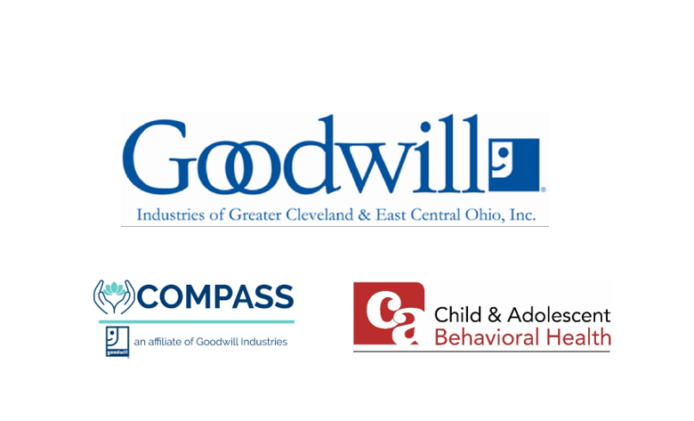

Employee Benefit Guide

Effective: March 1, 2026, through May 31, 2026

Table of Contents

Contents
Table of Contents 1
A Message from Goodwill Industries of Greater Cleveland and East Central Ohio 2
Medical Insurance 3
Dental Insurance 5
Vision Insurance 6
Health Savings Account (HSA) 7
Flexible Spending Accounts (FSA) 7
HSA vs FSA 7
Income Protection 8
Voluntary Life 9
Employee Assistance Program 10
Self-Care from AbleTo 11
403(b) Retirement Account 12
Accessing Your Benefits 13
Benefit Resource Center 14
Carrier Contacts 14

This brochure summarizes the benefit plans that are available to Child & Adolescent Behavioral Health,. eligible employees and their dependents. Official plan documents, policies and certificates of insurance contain the details, conditions, maximum benefit levels and restrictions on benefits. These documents govern your benefits program. If there is any conflict, the official documents prevail. These documents are available upon request through the Human Resources Department. Information provided in this brochure is not a guarantee of benefits.



A Message from Goodwill Industries of Greater Cleveland and East Central Ohio

In these pages, you will learn about the Goodwill Industries of Greater Cleveland and East Central Ohio benefits program, which is designed to help you stay healthy, secure, and maintain a work/life balance.

Offering a competitive benefits package is just one way we strive to provide our employees with a rewarding workplace. We work hard every year to evaluate benefit needs and negotiate the most cost-effective benefit packages. Due to this focus and our employees making wise decisions about their health, our medical plan rates have remained flat since 2021 while the average increase is between 4%-7% per year.

  - Who is Eligible?
Full-Time employees working at least 30 hours per week and their eligible dependents may participate in the benefit program.
Generally, eligible dependents are defined as:
- Your spouse
- Dependent child(ren) through the end of the month in which they turn 26. Coverage may continue past age 26 for disabled dependents if application is made to the carriers.

  - When and How Can I Enroll?
Benefit enrollment will begin Tuesday, January 13, and will run through Wednesday, January 28, 2026.

Scan the QR code to access benefits information and your enrollment form

When is Coverage Effective?
The Goodwill benefit plan runs June 1 to May 31. But during this special enrollment for Child & Adolescent Behavior Health employees, the plans will be effective March 1, 2026.
Coverage will remain in effect through the earliest of your date of separation, the plan year end date (5/31/2026), or you choose to terminate coverage due to a life event.
  - When Can I Change My Enrollment?
You can change coverage during the year only when you experience a qualifying life event, such as marriage, divorce, birth, adoption, placement for adoption, or loss of coverage. The change must be consistent with the event. You must notify HR and provide supporting documentation within 30 days of the event.
  - What if I Have Questions?
For questions about your benefits or enrollment options, call 800-942-3577 and ask to speak with a member of Human Resources or email hr@goodwillgoodskills.org.



Medical Insurance
You can choose either the Core HDHP or the Buy-Up PPO Plan through Anthem BlueCross BlueShield. Your premiums for this plan are deducted on a pre-tax basis.

Note: While the plan year runs June 1 through May 31, the deductible year runs from January 1 through December 31. During this special enrollment window for Child & Adolescent Behavioral Health, any current deductible amounts and Out of Pocket limits will be honored and transferred to your new plans.
Let’s review a few “insurance terms” that will help you with understanding your plan choices.

Copay: Flat dollar amount member is responsible for at the time of service. The plan usually pays 100% of the remaining balance.
Deductible: Amount member is responsible for before the plan pays for certain services.
Coinsurance: Percentage of payment shared between the member and the plan for certain services after the deductible has been met.
Network Provider: Medical and pharmacy providers that have contracted with the plan to provide lower out-of-pocket costs for members. To find an in-network provider, go to www.anthem.com/find-care.

 | Anthem Blue Cross and Blue Shield  Core Plan |  | Anthem Blue Cross and Blue Shield  Buy-Up Plan
 | In-Network Benefits | Out-of-Network Benefits | In-Network Benefits | Out-of-Network Benefits
Annual Deductible
Individual | $3,300 | $3,300 | $800 | $3,000
Family | $6,600 | $6,600 | $1,600 | $6,000
Coinsurance | 100% | 70% | 80% | 60%
Maximum Out-of-Pocket
Individual | $3,300 | $6,600 | $3,000 | $6,000
Family | $6,600 | $13,200 | $6,000 | $12,000
Physician Office Visit
Primary Care | 100% after deductible | 70% after deductible | $20 copay per visit | 60% after deductible
Specialty Care | 100% after deductible | 70% after deductible | $30 copay per visit | 60% after deductible
Preventive Care
Adult Periodic Exams | 100% | 70% after deductible | 100% | 60% after deductible
Well-Child Care | 100% | 70% after deductible | 100% | 60% after deductible
Diagnostic Services
X-ray and Lab Tests | 100% after deductible | 70% after deductible | 80% after deductible | 60% after deductible
Complex Radiology | 100% after deductible | 70% after deductible | 80% after deductible | 60% after deductible
Urgent Care Facility | 100% after deductible | 70% after deductible | $35 copay per visit | 60% after deductible
Emergency Room Facility Charges | 100% after deductible; waived if admitted | 100% after deductible; waived if admitted | $150 copay per visit; Waived if admitted | $150 copay per visit; Waived if admitted
Inpatient Facility Charges | 100% after deductible | 70% after deductible | 80% after deductible | 60% after deductible
Outpatient Facility and Surgical Charges | 100% after deductible | 70% after deductible | 80% after deductible | 60% after deductible
Mental Health
Inpatient | 100% after deductible | 70% after deductible | 80% after deductible | 60% after deductible
Outpatient | 100% after deductible | 70% after deductible | 80% after deductible | 60% after deductible
Substance Abuse
Inpatient | 100% after deductible | 70% after deductible | 80% after deductible | 60% after deductible
Outpatient | 100% after deductible | 70% after deductible | 80% after deductible | 60% after deductible
Other Services
Chiropractic | 100% after deductible; 12 visits per year | 70% after deductible | 80% after deductible; 20 visits per year | 60% after deductible
Retail Pharmacy (30 Day Supply)
Generic (Tier 1) | 0% after deductible | 30% after deductible | $10 copay | $60 or 50%
Preferred (Tier 2) | 0% after deductible | 30% after deductible | $30 copay | $60 or 50%
0Non-Preferred (Tier 3) | 0% after deductible | 30% after deductible | $60 copay | $60 or 50%
Preferred Specialty (Tier 4) | 0% after deductible | 30% after deductible | N/A | N/A
Mail Order Pharmacy (90 Day Supply)
Generic (Tier 1) | 0% after deductible | Not covered | $10 copay | Not covered
Preferred (Tier 2) | 0% after deductible | Not covered | $75 copay | Not covered
Non-Preferred (Tier 3) | 0% after deductible | Not covered | $180 copay | Not covered
Preferred Specialty (Tier 4) | 0% after deductible | Not covered | N/A | N/A

Employee Contributions: Medical
Core Plan
 | Total Cost per Month | Company’s Cost per Month | Your Cost per Month | Your cost per Pay
Employee | $683.28 | $585.28 | $98.00 | $49.00
Employee & Spouse | $1,434.90 | $1,098.90 | $336.00 | $168.00
Employee & Child(ren) | $1,264.07 | $1,070.07 | $194.00 | $97.00
Family | $2,015.69 | $1,585.69 | $430.00 | $215.00
Buy-Up PPO Plan
 | Total Cost per Month | Company’s Cost per Month | Your Cost per Month | Your cost per Pay
Employee | $752.13 | $614.13 | $138.00 | $69.00
Employee & Spouse | $1,579.47 | $1,157.47 | $422.00 | $211.00
Employee & Child(ren) | $1,391.44 | $1,123.44 | $268.00 | $134.00
Family | $2,218.78 | $1,666.78 | $552.00 | $276.00
***Tobacco users pay an additional $10.00 per pay in both plans. ***

Wellness Disclosure: Rewards for being a non-tobacco user are available to all employees enrolled in a medical plan. If you are unable to meet the non-tobacco standard for a reward under this wellness program, you might qualify for an opportunity to earn the same reward by completing the free Ohio Tobacco Quit Line tobacco cessation program. Participants that successfully complete this program will receive the $10 per pay discount. Call 1-800-QUIT-NOW (1-800-784-8669) to speak with a program specialist.


Dental Insurance
Although you can go to any dentist you wish using a Sun Life PPO network provider, your plan year maximum will stretch further if you go to an in-network who offers discounts on their usual fees. To find a provider, visit www.sunlife.com/findadentist.

Note: While the plan year runs June 1 - May 31, the benefit year runs from January 1 - December 31 for deductible and accumulation purposes.
The chart below is a brief outline of the plan.

 | Low Plan |  | High Plan
 | In-Network Benefits | Out-of-Network Benefits | In-Network Benefits | Out-of-Network Benefits
Annual Deductible
Individual | $0 | $0 | $50 | $50
Family | $0 | $0 | $150 | $150
Waived for Preventive Care | Yes | Yes | Yes | Yes
Annual Maximum
Per Person / Family | $1,000 | $1,000 | $1,500 | $1,500
Preventive | 100% after deductible | 100% after deductible | 100% after deductible | 100% after deductible
Basic | 80% after deductible | 50% after deductible | 100% after deductible | 80% after deductible
Major | 50% after deductible | 25% after deductible | 60% after deductible | 50% after deductible
Orthodontia
Benefit Percentage | Not covered | Not covered | 50% after deductible | 50% after deductible
Adults (and Covered Full-Time Students, if Eligible) | Not covered | Not covered | Not covered | Not covered
Dependent Child(ren) | Not covered | Not covered | Covered up to age 26 | Covered up to age 26
Lifetime Maximum | N/A | N/A | $1,000 | $1,000
Employee Contributions: Dental
Low Plan
 | Total Cost per Month | Company’s Cost per Month | Your Cost per Month | Your cost per Pay
Employee | $14.26 | $7.13 | $7.13 | $3.57
Employee & Spouse | $32.39 | $16.20 | $16.20 | $8.10
Employee & Child(ren) | $36.08 | $18.04 | $18.04 | $9.02
Family | $53.43 | $26.72 | $26.72 | $13.36
Buy-Up PPO Plan
High Plan
 | Total Cost per Month | Company’s Cost per Month | Your Cost per Month | Your cost per Pay
Employee | $27.57 | $13.79 | $13.79 | $6.89
Employee & Spouse | $58.61 | $29.31 | $29.31 | $14.65
Employee & Child(ren) | $65.26 | $32.63 | $32.63 | $16.32
Family | $96.37 | $48.19 | $48.19 | $24.09



Vision Insurance
Vision benefits are available for you and your family for a minimal cost per paycheck through Sun Life. This plan includes benefits for one annual routine eye exam and your choice of eyeglasses or contact lenses, if applicable. Although you can go to any vision provider you choose, you will need to go to a participating network provider for the highest level of coverage.
The plan year runs June 1-May 31. The annual benefit is based on service frequency, which indicates when you will be eligible again for an exam or materials. To find a provider, call VSP at 1-800-877-7195 or log-in using www.vsp.com. Your premiums are deducted on a pre-tax basis.
 | In-Network
Eye Examination
Routine Eye Examination | 100% after $10 copay
Lenses and Frames
Lenses (Single, Bifocal, Trifocal, Lenticular) | 100% after $25 copay
Frames | 100% up to $130 allowance; 20% off amounts over allowance
Contact Lenses
Elective Contact Lenses | $130 for contact lenses;  15% savings for contact lens exam (fitting and evaluation)
Medically Necessary Contact Lenses | 100% after $25 copay

 | Frequency
Routine Eye Examination | Every 12 months
Eyeglass Lenses OR Contact Lenses | Every 12 months
Eyeglass Frames | Every 24 months
Note: You can choose either eyeglass lenses or contact lenses every 12 months.

Employee Contributions: Vision

 | Your Cost per Month | Your Cost per Pay
Employee | $5.14 | $2.57
Employee & Spouse | $9.35 | $4.68
Employee & Child(ren) | $9.36 | $4.68
Family | $16.07 | $8.04



Health Savings Account (HSA)
Health Savings Accounts complement High-Deductible Health Plans. They offer triple tax advantages by allowing you to make pre-tax contributions from your paycheck, invest your funds to grow your savings (interest and earnings grow tax free), and take tax free distributions from the account for current or future eligible expenses.
To participate, you must be enrolled in the Medical Core Plan. You will need to set up your own Health Savings Account at a bank of your choice and provide Human Resources with your account information.

Flexible Spending Accounts (FSA)

Healthcare Flexible Spending Account (Health FSA)
This account allows you to fund eligible expenses such as copays and deductibles, with pre-tax dollars. By paying for out-of-pocket medical expenses with pre-tax dollars, you do not pay Federal Income Tax or FICA tax on your contributions.


Dependent Care Account
This account allows you to fund the costs of care, on a pre-tax basis, for your dependent children aged 12 and younger and adult tax dependents who require care while you are at work. You may contribute up to a maximum of $5,000 each year, per household. The plan year runs June 1 – May 31 and unused funds are forfeited after the 2 ½ month grace period following the end of the plan year.

HSA vs FSA
General information about the Health Savings Account (HSA) and the Health Flexible Spending Account (FSA) is shown in the chart below. Speak to your tax or legal advisor about your specific tax and benefit situation.
 | Health Savings Account (HSA) | Health Care  Flexible Spending Account (FSA)
Eligibility | Requires enrollment in the  Core HDHP Plan | Any FT benefit eligible employee
Limitations | When also enrolled in an FSA, the FSA can only be used on dental/vision expenses | When also enrolled in an HSA, the FSA can only be used on dental/vision expenses
Max Contribution | $4,400 Single  $8,750 Family  $1,000 “Catch-Up” for ages 55-65 | $3,300
Funds Availability | Funds must be in account before reimbursements are paid | All funds available at start of plan year
What happens to unused funds? | Unused funds accumulate year after year | Rollover up to $660 of unused funds to the next plan year
Account Ownership | Personal bank account owned by the employee; funds are always yours | Account is owned by the employer, funds are “use it or lose it”
Contribution Changes | Changes can be made anytime | Changes only allowed at Open Enrollment unless you experience a Qualifying Event
Plan Year | 1/1/25-12/31/25 | 3/1/26-5/31/26
Eligible Expenses | Deductibles, medical services, over-the-counter drugs, prescriptions, dental treatment, menstrual care products, eyeglasses. Visit https://www.irs.gov/pub/irs-pdf/p502.pdf for a complete list

Income Protection
No cost to you!

At Goodwill, we offer NO COST plans designed to protect your income in the event of childbirth, serious injury, illness, dismemberment, or death.

All eligible employees are automatically enrolled in Basic Life and AD&D, Short-Term Disability and Long-Term Disability plans through Sun Life.

To ensure plan benefits are distributed according to your wishes, you must name a beneficiary on your enrollment form.

Basic Life and AD&D
Employee Amount |  | 1.5x basic annual earnings
Benefit Maximum |  | $300,000
Accidental Death Benefit |  | In the event of an accidental death, this benefit may double. Please see your booklet for further details.
Dismemberment |  | In the event of an accidental dismemberment, a benefit is provided up to a scheduled amount corresponding to the loss.
Benefit Reduction Schedule |  | Benefit amount reduced by 35% at age 65, 60% at age 70, 75% at age 75 and 85% at age 80. Benefits terminate upon retirement.
Disability
 | Short-Term Disability |  | Long-Term Disability
Benefit Amount | 60% of weekly salary (up to $2,000) |  | 60% of monthly salary (up to $10,000)
Benefits Begin | 1st day for injury  8th day for illness |  | After 90 days of disability
Maximum Benefit Duration | 13 weeks |  | Up to your Social Security Normal Retirement Age or longer, depending on your age at disability.
Pre-Existing Condition | N/A |  | 12 months for a condition treated within 3 months prior to effective date of coverage.

Voluntary Life
Additional life insurance coverage is available for you, your spouse, and your children through Sun Life. Rates are age-based and will be calculated for you as you complete your enrollment. Costs for this plan are deducted through post-tax payroll deductions.

Employee
Newly hired employee guaranteed coverage amount | $200,000
Continuing employee guaranteed coverage annual increase amount | Choice of $25,000
Maximum coverage amount | 10x annual salary ($200,000 maximum in increments of $25,000)
Minimum coverage amount | $25,000
Spouse
Newly hired employee guaranteed coverage amount | $25,000
Continuing spouse guaranteed coverage annual increase amount | Choice of $12,500
Maximum coverage amount | 50% of the employee coverage amount ($50,000 maximum in increments of $12,500)
Minimum coverage amount | $12,500
Dependent Children
Age 6 months to 26 years | $10,000
Age 14 days to 6 months guaranteed coverage amount | $250

Guaranteed Life Insurance Coverage Amount
- Initial Open Enrollment: When you are first offered this coverage, you and your spouse can choose a coverage amount up to the guaranteed issue amount without providing evidence of insurability. If you decline this coverage now and wish to enroll later, evidence of insurability may be required and may be at your own expense.

- Annual Limited Enrollment: If you are a continuing employee, you can increase your coverage amount by $25,000 ($12,500 for your spouse), subject to plan maximums, without providing evidence of insurability. If you submitted evidence of insurability in the past and were declined for medical reasons, you may be required to submit evidence of insurability.

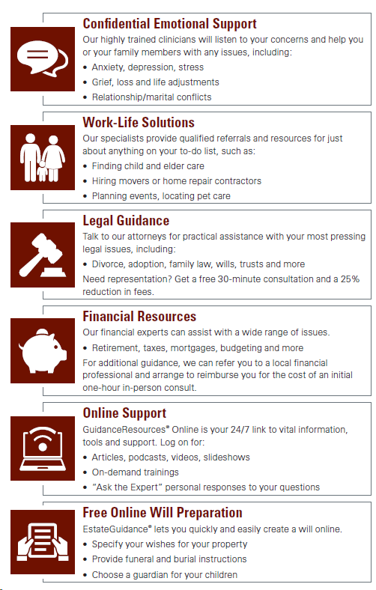
Employee Assistance Program
No cost to you!


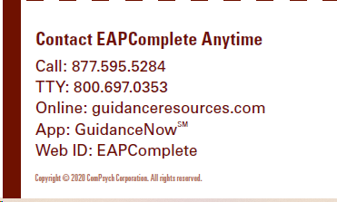
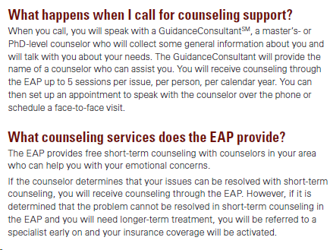

Self-Care from AbleTo
No cost to you!

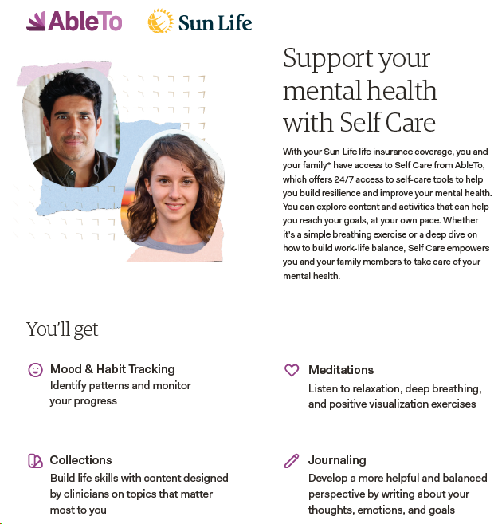

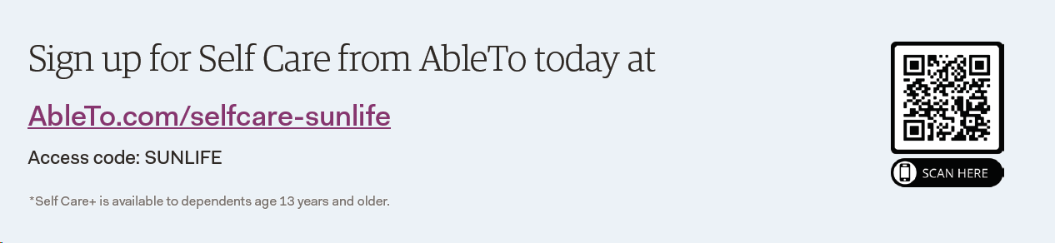


403(b) Retirement Account
Goodwill offers a 403(b) Retirement Plan with Agency match through Mutual of America. This benefit is available to both Full-time and Part-time Employees.
You may join the plan at any time by visiting www.mutualofamerica.com/signup.

Eligibility | All employees (Full-time and Part-time)
Enrollment window | Enroll any time, no waiting period
Agency Match Amount | $0.50 for every $1.00 you contribute, up to the first 8% of your income
Agency Match Eligibility | 1 year of service, at least 1,000 hours worked in the last year, and at least 21 years old
Vesting | The funds you contribute are always yours; Agency contributions will be considered vested and become employee funds after three years of employment



Accessing Your Benefits
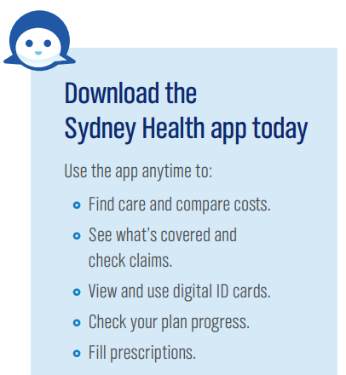
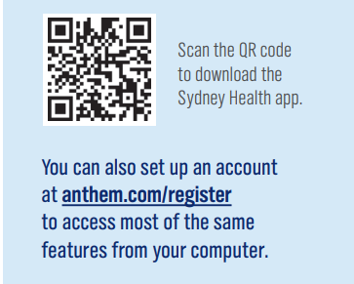


Your medical ID card and FSA debit card will be mailed directly to your home address. For your dental coverage, you can access your ID card conveniently online through the Sun Life website, and your vision card is available on the VSP website. Need a replacement card for any of these benefits? Contact the Benefit Resource Center at 855-874-0829 or by sending an email to BRCMidwest@usi.com.
Medical Anthem (Group # W43330)
Access personalized health and wellness information wherever you are! The Sydney Health mobile app is the one place to keep track of your health and your benefits.
With a few taps, you can quickly access your plan details, Member Services, virtual care, and wellness resources.

Dental Sun Life (Group # 966825)
It is easy to find information about your dental benefits when you register for your Sun Life online account! To sign up, visit www.sunlife.com/account. You will need your social security number and date of birth to register. After registering, you can:

- Print an ID card
- Check claim status
- Estimate the cost of a dental procedure
- View plan details

Vision Sun Life (Group # 966825)
Online access to your vision benefits is available at www.vsp.com. You will need your social security number to create an account. By registering, you will be able to:

- Find a provider
- See your coverage and costs
- View a list of covered contact lens brands
- Learn how to use your vision benefits


  - Employee Assistance Program Employee Connect ComPsych – Guidance Resources
Easily connect to the help you need, when you need it, with the Employee Connect ComPsych – Guidance Resources Worldwide website or app. Scan the QR code or visit www.guidanceresources.com. Register using web ID: EAPComplete

  - Self-Care AbleTo
With Self Care from AbleTo, you can learn how to improve your mood, become more resilient to change, manage stress and feel more in control. To sign up, visit www.AbleTo.com/selfcare-sunlife and register using access code: SUNLIFE

Benefit Resource Center
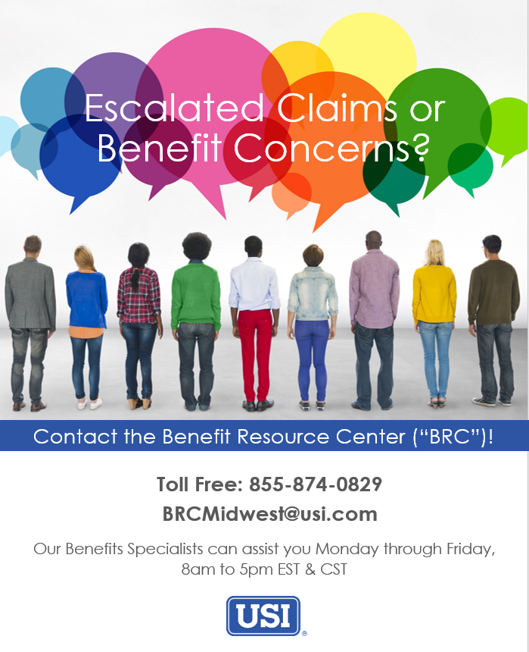
Child & Adolescent Behavioral Health has partnered with the USI Benefit Resource Center (BRC) to give you additional support for all your benefit needs including escalated claims, eligibility problems, and ID card assistance.

You can reach a Benefits Specialist at the BRC Monday through Friday 8:00 a.m. to 5:00 p.m. Eastern & Central Standard Time at 855-874-0829 or via e-mail at BRCMidwest@usi.com.
If you need assistance outside of regular business hours, please leave a message and one of the Benefit Specialists will promptly return your call or e-mail message by the end of the following business day.


Carrier Contacts
Benefits Plan | Carrier/Group Number | Phone Number | Website
Medical (Buy-Up and Core) | Anthem Blue Cross and Blue Shield  Group ID: W43330 | 833-639-1634 | www.anthem.com
Dental (Buy-Up and Core) | Sun Life  Group ID: 966825 | 800-442-7742 | www.sunlife.com/account
Vision | Sun Life  Group ID: 966825 | 800-877-7195 | www.vsp.com
Basic Life and AD&D | Sun Life  Group ID: 966825 | 800-247-6875 | www.sunlife.com/account
Voluntary Life | Sun Life  Group ID: 966825 | 800-247-6875 | www.sunlife.com/account
Short Term Disability (STD) | Sun Life  Group ID: 966825 | 800-247-6875 | www.sunlife.com/account
Long Term Disability (LTD) | Sun Life  Group ID: 966825 | 800-247-6875 | www.sunlife.com/account
Employee Assistance Program | EAPComplete through  ComPsych – Guidance Resources | 877-595-5284 | www.guidanceresources.com
Flexible Spending Account | Chard Snyder | 800-982-7715 | www.chard-snyder.com
403(b) Retirement Plan | Mutual of America | 330-576-7012 | www.mutualofamerica.com/signup

